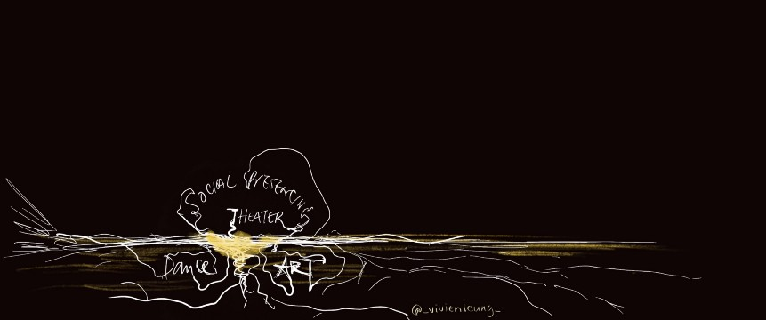**The Origins of Social Presencing Theatre**

A group of advanced Social Presencing Theatre practitioners gathered together in Denmark in January 2020 as part of the Presencing Institute’s research initiative aimed at developing and showcasing SPT, both as a methodology for action research and as a support for the evolution of social systems through the development of tools, methods and protocols.

Social Presencing Theatre is an awareness-based action research methodology for making social fields visible, and a tool for enabling deep systemic change. Its wisdom lies it is simplicity. It strips philosophical insight and deep practice back to 8 engaged practices that access the essence of our being and practice awareness of ourselves, in relation to the whole. Ultimately SPT is an invitation to work with the sanity inherent in our humanity, and the systems we are part of and act from there. It embraces a rich tradition that is not bound by any one discipline or profession. And, importantly, it is accessible to all who wish to access their innate wisdom and act from the collective intelligence available to us all at this time.

Arawana describes SPT as having roots in “***mindfulness-awareness, in embodiment, in the performing arts, and in a conviction that the nonverbal experience of “feeling” can be a gateway to accessing wisdom*”** in a conference paper in 2017 where she also outlines the evolution of the different practices. In addition to these traditions, the influence of philosophy, psychology, and systems thinking, can also be seen as a grounding for understanding the practice.

During one part of our collective inquiry in Denmark, we began the process of excavating the origins surrounding the evolution of the practice. For me, it seemed important to articulate **its rich academic heritage for doctoral studies.** Ultimately, it was edifying to hear others call out the names those whose inquiring hearts and minds underpin the ground on which the practice and we as practitioners stand. This brief paper briefly sketches out **the influences that constellate to bring forth the practice of SPT** as mediated through the collaboration between Arawana Hayashi and Otto Scharmer. It is coloured by the inputs of the 16 researchers along with Arawana and even so, it is a watercolour of influences on moving ground, subject to further refinement and evolvement. Embodied knowing is not bound by philosophical knowledge and neat boundaries!

It started with a flipchart pinned to a full length window and a rough system map with different disciplines in bubbles to which we brainstormed names and I scribbled them down as fast as I could. System maps are a way to draw together different elements and show the components and boundary of a system at a point in time, they help structure a system in a simple way that can be communicated to others. This system map gathers together of a range of influences or ingredients if you like that contributed to how SPT has been shaped as a practice. It does so, whilst acknowledging that there is also a rich narrative in the real life complexity involved in weaving theory and practice over time to fine-tune praxis.

.

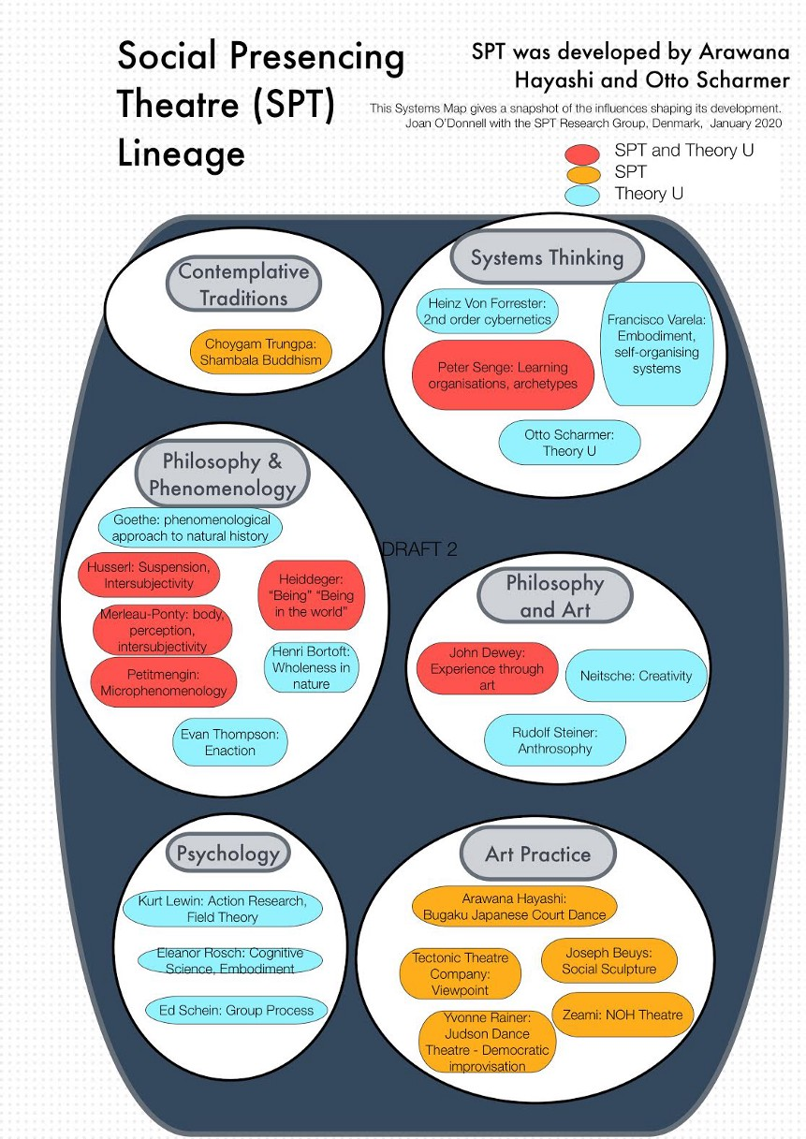

***The System Map diagram (Fig 1) distinguishes between those that Arawana Hayashi brought to the mix (coded in orange) and those that have influenced the development of Theory U (coded in blue) and also references thinking that have found expression in both Theory U and SPT (red).***

**To Reference:**O’Donnell, Joan (2020): The Origins of Social Presencing Theatre. figshare. Online resource. <https://doi.org/10.6084/m9.figshare.12408818.v1>

**References:**

Hayashi, Arawana (2017) “*Social Presencing Theatre, Listening to our body-knowing to access the wisdom that lives in us?”* Wisdom Together, “Conscious Leadership” Conference, Oslo, Norway.

*With thanks to Vivien Leung for her drawing inspired by our discussion.*[www.vivienleung.co](http://www.vivienleung.co/)



***The System Map diagram (Fig 1) distinguishes between those that Arawana Hayashi brought to the mix (coded in orange) and those that have influenced the development of Theory U (coded in blue) and also references thinking that have found expression in both Theory U and SPT (red).***

**To Reference:**O’Donnell, Joan (2020): The Origins of Social Presencing Theatre. figshare. Online resource. <https://doi.org/10.6084/m9.figshare.12408818.v1>

**References:**

Hayashi, Arawana (2017) “*Social Presencing Theatre, Listening to our body-knowing to access the wisdom that lives in us?”* Wisdom Together, “Conscious Leadership” Conference, Oslo, Norway.

*With thanks to Vivien Leung for her drawing inspired by our discussion.*[www.vivienleung.co](http://www.vivienleung.co/)

209

2